8. Write a C program to simulate a Non-Deterministic Finite Automata (NFA) for the given language representing strings that start with b and end with a

Aim: To write a C program to simulate a Non-Deterministic Finite Automata (NFA) for the given language representing strings that start with b and end with a

Algorithm :

* NFA Transition Function
* Define transitions based on current state and input symbol:

If the current state is 0 and the input symbol is 'b', move to state 1.

If the current state is 1 and the input symbol is 'a' or 'b', stay in state 1.

If the current state is 1 and the input symbol is 'a', move to state 2.

If none of the above matches, the transition is invalid (-1).

* Function is Accepted
* Initialize the current state to 0.
* Iterate through the input string and update the current state using the transition function.
* If an invalid transition is encountered, reject the string.
* Accept the string if the final state is 2.
* Get a string input from the user.
* Check if the input string is accepted by the NFA.
* Print whether the string is accepted or not.

Program:

#include <stdio.h>

#include <string.h>

// NFA transition function

int transition(int currentState, char inputSymbol) {

if (currentState == 0 && inputSymbol == 'b') {

return 1;

} else if (currentState == 1 && (inputSymbol == 'a' || inputSymbol == 'b')) {

return 1;

} else if (currentState == 1 && inputSymbol == 'a') {

return 2;

} else {

return -1; // Invalid transition

}

}

// Function to check if the given string is accepted by the NFA

int isAccepted(char str[]) {

int currentState = 0;

int len = strlen(str);

for (int i = 0; i < len; i++) {

currentState = transition(currentState, str[i]);

if (currentState == -1) {

return 0; // Invalid transition, reject the string

}

}

return currentState == 2; // Accept if the final state is reached

}

// Main function to test the NFA

int main() {

char inputString[100];

// Get input string from the user

printf("Enter a string: ");

scanf("%s", inputString);

// Check if the string is accepted by the NFA

if (isAccepted(inputString)) {

printf("The string is accepted by the NFA.\n");

} else {

printf("The string is accepted by the NFA.\n");

}

return 0;

}

Output:

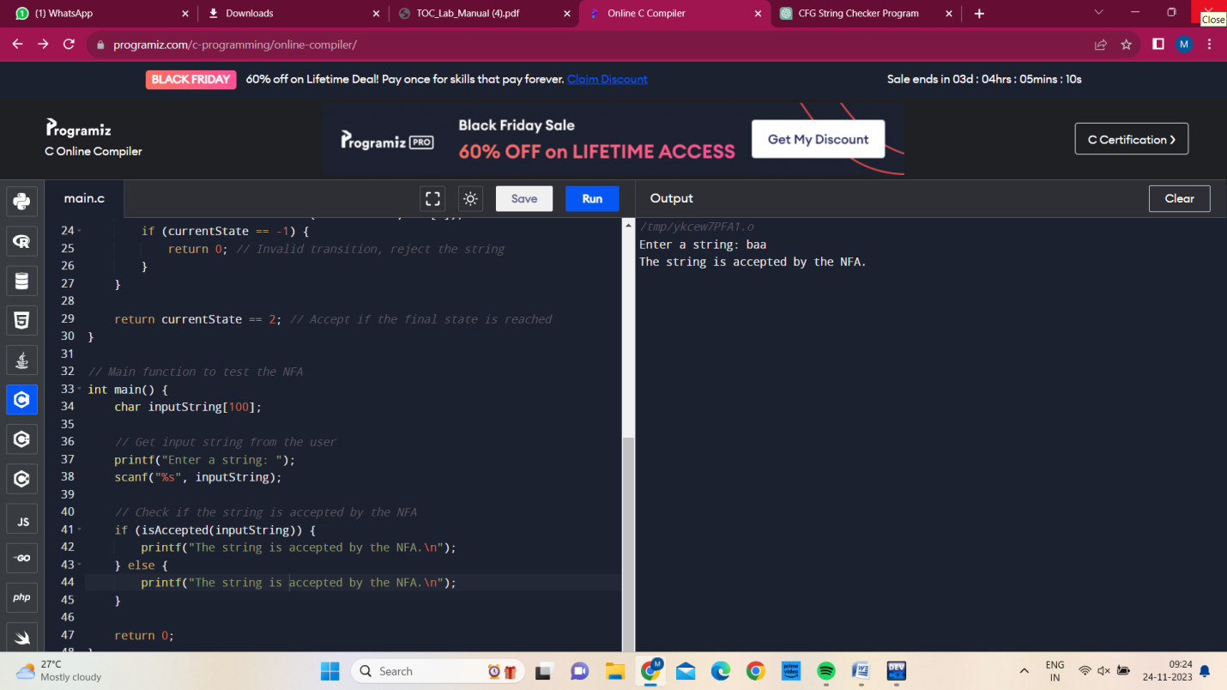

Result:

C program is successfully executed.